**MOBILE APP SECURITY ASSESSMENT USING STATIC ANALYSIS**

**MOBILE SECURITY FRAMEWORK (MobSF)**

SHERYL TREFINA J

[sheryltrefina04@gmail.com](mailto:sheryltrefina04@gmail.com)

**TABLE OF CONTENTS:**

**1. INTRODUCTION**

1.1 Purpose of the Report

1.2 Scope of Analysis

1.3 Overview of Mobile Application Security

**2. OVERVIEW OF MOBSF**

2.1 Introduction to MobSF

2.2 Key Features

2.3 Benefits of Using MobSF for Static Analysis

**3. METHODOLOGY**

3.1 Preparation and Setup

3.2 Static Analysis Process

**4. STATIC ANALYSIS PROCESS USING MOBSF**

4.1 APK/IPA Scanning

4.2 Code Analysis

4.3 Certificate Analysis

4.4 Malware Analysis

**5. INTERPRETATION OF RESULTS**

5.1 Impact of Identified Vulnerabilities

5.2 Recommendations for Mitigation

5.3 Best Practices for Secure Mobile App Development

**6. CONCLUSION**

6.1 Importance of Static Analysis in Mobile Security

6.2 Screenshots

**1. INTRODUCTION:**

**1.1 PURPOSE OF THE REPORT**

The purpose of this report is to provide a comprehensive analysis of mobile application security using static analysis techniques, specifically utilizing the Mobile Security Framework (MobSF). This report aims to identify potential vulnerabilities and insecure coding practices within mobile applications, offering insights and recommendations for improving security. By thoroughly examining the static components of mobile applications, this report seeks to highlight the importance of proactive security measures and the role of static analysis in the overall security assessment process.

**1.2 SCOPE OF ANALYSIS**

The scope of this analysis includes evaluating mobile applications for security vulnerabilities through static analysis using MobSF. This report covers:

- The setup and use of MobSF for scanning Android (APK) and iOS (IPA) applications.

- Analysis of the source code and binary files for identifying security weaknesses.

- Examination of application certificates for integrity and validity.

- Detection of potential malware within the application package.

- Providing detailed findings, interpretations, and recommendations for enhancing mobile application security based on the analysis results.

**1.3 OVERVIEW OF MOBILE APPLICATION SECURITY**

Mobile application security is a critical aspect of the software development lifecycle, aimed at protecting applications from threats and vulnerabilities that can lead to data breaches, unauthorized access, and other security incidents. With the increasing reliance on mobile apps for various personal and professional activities, ensuring their security is paramount. Key aspects of mobile application security include:

**- Confidentiality:** Protecting sensitive information from unauthorized access.

**- Integrity:** Ensuring that data is not altered or tampered with during storage or transmission.

**- Authentication:** Verifying the identity of users and ensuring secure access to the application.

**- Authorization:** Ensuring that users have appropriate permissions for accessing resources within the application.

**- Data Encryption:** Using encryption techniques to protect data at rest and in transit.

**- Secure Coding Practices:** Implementing best practices in coding to avoid common vulnerabilities such as SQL injection, cross-site scripting (XSS), and insecure data storage.

**- Regular Security Testing:** Conducting regular security assessments, including static and dynamic analysis, to identify and mitigate vulnerabilities early in the development process.

**2. OVERVIEW OF MobSF**

**2.1 INTRODUCTION TO MobSF**

The Mobile Security Framework (MobSF) is an open-source automated security testing tool specifically designed for mobile applications. It supports static and dynamic analysis of Android, iOS, and Windows apps, providing comprehensive insights into their security posture. MobSF is widely recognized for its ability to perform deep analysis on mobile application binaries (APK/IPA) and source code, detecting a wide range of security issues. By leveraging MobSF, developers and security professionals can identify vulnerabilities, insecure coding practices, and other potential threats within mobile applications early in the development lifecycle.

**2.2 KEY FEATURES**

MobSF offers a rich set of features that make it a powerful tool for mobile application security testing. Key features include:

**- STATIC ANALYSIS:**

**- APK/IPA Scanning:** Analyze Android and iOS application packages without requiring source code access.

**- Code Analysis:** Detect insecure coding practices, vulnerabilities, and other security issues within the source code.

**- Binary Analysis:** Assess the security of binary files to identify known vulnerabilities and potential risks.

**- Certificate Analysis:** Verify the integrity and validity of application certificates to ensure they are not compromised.

**- Malware Analysis:** Identify malicious components or behavior within the application package.

**2.3 BENEFITS OF USING MobSF FOR STATIC ANALYSIS**

Using MobSF for static analysis offers numerous benefits, making it an essential tool for enhancing mobile application security:

**- Early Detection of Vulnerabilities:** MobSF helps identify security issues early in the development process, allowing for timely remediation and reducing the risk of vulnerabilities being exploited in production.

**- Comprehensive Analysis:** MobSF provides a thorough examination of mobile applications, covering various aspects such as code, binary files, certificates, and potential malware, ensuring no stone is left unturned.

**- Automated Testing:** Automating the static analysis process with MobSF saves time and effort, enabling developers to focus on fixing issues rather than manually searching for them.

**- Cost-Effective Security:** As an open-source tool, MobSF provides a cost-effective solution for mobile application security testing, eliminating the need for expensive commercial tools.

**- Improved Compliance:** By incorporating checks for OWASP Mobile Top 10 vulnerabilities, MobSF helps ensure that applications comply with industry-standard security guidelines.

**3. METHODOLOGY**

**3.1 PREPARATION AND SETUP**

To effectively utilize MobSF for static analysis, it is essential to follow a structured preparation and setup process:

**1. ENVIRONMENT SETUP:**

- Ensure you have a stable environment for running MobSF. MobSF can be run on various platforms, including Windows, Linux, and macOS.

- Install the necessary dependencies, such as Python, Docker (optional but recommended for easier setup), and other required libraries.

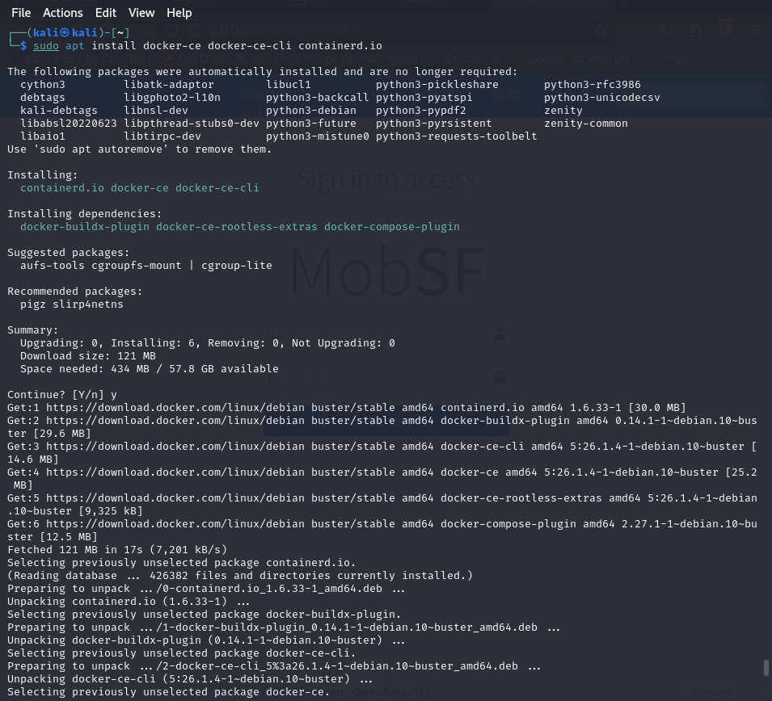

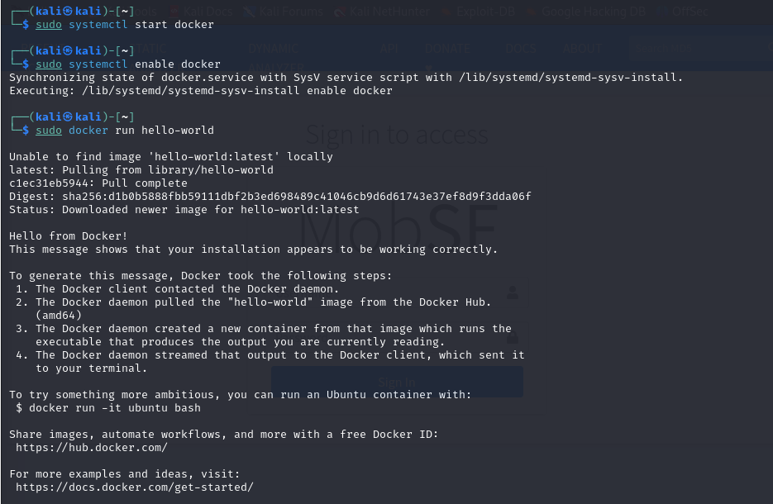

**2. INSTALLING MOBSF:**

- Download the latest version of MobSF from its [GitHub repository] (https://github.com/MobSF/Mobile-Security-Framework-MobSF).

- Follow the installation instructions provided in the repository. This typically involves cloning the repository and running the setup scripts.

**3. CONFIGURING MOBSF:**

- Configure MobSF settings according to your needs. This includes setting up the database, configuring network settings, and adjusting analysis parameters.

- Ensure that MobSF has access to the necessary tools and SDKs for analyzing Android and iOS applications.

**4. PREPARING THE MOBILE APPLICATIONS:**

- Obtain the APK (Android) and IPA (iOS) files of the mobile applications you intend to analyze.

- Ensure that the applications are ready for analysis, with no obfuscation or encryption that might hinder the static analysis process.

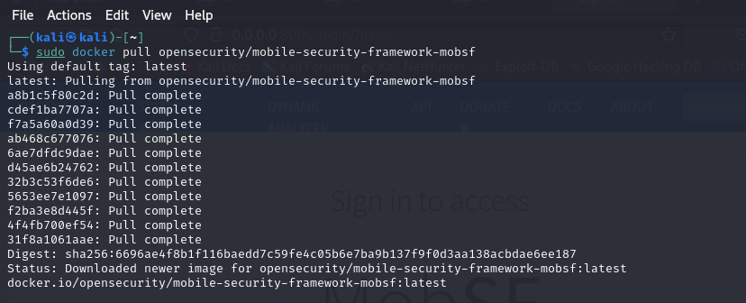

**3.2 STATIC ANALYSIS PROCESS**

The static analysis process using MobSF involves several key steps:

**1. UPLOADING THE APPLICATION:**

- Start the MobSF server and access the MobSF web interface.

- Upload the APK or IPA file to the MobSF interface. MobSF will automatically start the analysis process once the file is uploaded.

**2. ANALYZING THE APPLICATION:**

- MobSF performs a series of automated checks and scans on the uploaded application. This includes decompiling the APK/IPA, extracting the source code, and analyzing the code for security vulnerabilities.

- The analysis covers various aspects, such as code quality, insecure coding practices, binary file integrity, certificate validity, and potential malware.

**3. GENERATING REPORTS:**

- Once the analysis is complete, MobSF generates detailed reports summarizing the findings.

- The reports include identified vulnerabilities, their severity levels, and recommendations for remediation.

- Additional insights, such as API usage, permission analysis, and potential data leaks, are also included in the reports.

**4. REVIEWING AND INTERPRETING RESULTS:**

- Review the generated reports to understand the identified issues and their potential impact on the application’s security.

- Prioritize the remediation efforts based on the severity of the vulnerabilities and the criticality of the application.

**4. STATIC ANALYSIS PROCESS USING MOBSF**

**4.1 APK/IPA SCANNING**

MobSF efficiently scans APK (Android) and IPA (iOS) files to start the static analysis process. When an application file is uploaded, MobSF decompiles it to access its underlying structure and content, extracting manifest files, resource files, and other components necessary for thorough analysis.

**4.2 CODE ANALYSIS**

In the code analysis phase, MobSF inspects the decompiled source code for security vulnerabilities and insecure coding practices. This includes:

- Identifying hardcoded secrets, such as API keys and passwords.

- Detecting the use of insecure or deprecated APIs.

- Examining code for common security flaws like SQL injection and cross-site scripting (XSS).

- Reviewing the application's permission requests for security implications.

**4.3 CERTIFICATE ANALYSIS**

Certificate analysis in MobSF verifies the integrity and validity of the application's digital certificates by:

- Checking the certificate chain for proper signing and trust.

- Verifying expiration dates to prevent the use of outdated certificates.

- Ensuring certificates are not self-signed unless necessary.

- Detecting certificate pinning to prevent man-in-the-middle attacks.

**4.4 MALWARE ANALYSIS**

MobSF performs malware analysis to detect malicious components or behaviors within the application by:

- Scanning for known malware signatures using integrated databases.

- Analyzing the application's behavior for suspicious activities, such as unauthorized data access or communication with malicious servers.

- Checking for embedded payloads, backdoors, or other malicious code.

**5. INTERPRETATION OF RESULTS**

**5.1 IMPACT OF IDENTIFIED VULNERABILITIES**

Identifying vulnerabilities in mobile applications through tools like MobSF can have significant impacts on security:

**- Data Breaches:** Vulnerabilities may expose sensitive user data to unauthorized access.

**- Financial Loss:** Exploited vulnerabilities can lead to financial losses through fraud or theft.

**- Reputation Damage:** Security breaches can damage the app's reputation and erode user trust.

**- Legal and Compliance Issues:** Non-compliance with data protection regulations may result in legal consequences.

**5.2 RECOMMENDATIONS FOR MITIGATION**

To mitigate identified vulnerabilities, follow these recommendations:

**- Patch Management:** Regularly update the application with security patches and fixes.

**- Secure Coding Practices:** Adhere to secure coding guidelines to prevent common vulnerabilities.

**- Penetration Testing:** Conduct regular penetration testing to identify and address security weaknesses.

**- Encryption:** Encrypt sensitive data in transit and at rest to protect against unauthorized access.

**- User Education:** Educate users about security best practices and potential risks.

**5.3 BEST PRACTICES FOR SECURE MOBILE APP DEVELOPMENT**

Implement these best practices to enhance mobile app security:

**- Use Secure Libraries and APIs:** Use trusted libraries and APIs with strong security measures.

**- Authentication and Authorization:** Implement robust authentication and authorization mechanisms.

**- Data Minimization:** Collect only necessary data and minimize storage of sensitive information.

**- Code Reviews:** Conduct regular code reviews to identify and fix security issues early.

**- Privacy by Design:** Incorporate privacy protections throughout the app development lifecycle.

**- Monitoring and Logging:** Implement logging and monitoring to detect and respond to security incidents.

**6. CONCLUSION**

**6.1 IMPORTANCE OF STATIC ANALYSIS IN MOBILE SECURITY**

Static analysis plays a crucial role in ensuring the security and reliability of mobile applications throughout their development lifecycle. By examining the application's code and binaries without execution, static analysis helps identify potential security vulnerabilities, design flaws, and coding errors that could compromise the application's security. This proactive approach allows developers and security professionals to detect and address issues early, reducing the likelihood of vulnerabilities being exploited in production environments.

Furthermore, static analysis contributes to maintaining compliance with security standards and regulations by identifying deviations from best practices and security guidelines. It provides a foundation for implementing secure coding practices, ensuring that mobile applications are built with security in mind from the outset. This approach not only protects sensitive user data but also safeguards the reputation of the organization by minimizing the risk of security breaches and data leaks.

**6.2 SCREENSHOTS**

